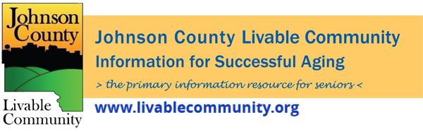

May 2022 Newsletter
In this month's issue:
- Older Americans Month Programs
- Direct Assistance Program
- Primary Election Information
- Senior Farmer's Market Nutrition Program
- Farmer's Markets
- Dementia Friendly Community
- REAL ID
- Johnson County Caregiver Event
- Powerful Tools for Caregivers
- Local Programming and News
Older Americans Month 2022
May is Older Americans Month(OAM) and this year's theme is "Age My Way."
Johnson County Livable Community (JCLC) is a resource available to all in Johnson County. JCLC's mission is to serve as a unifying structure that fosters effective collaboration, communication, and education that will build and sustain a livable community for successful aging.
See the flyer and events listed below or for a full list of events go to www.johnsoncountyiowa.gov/older-americans-month or call the Aging Specialist at 319-356-6090 for more information.
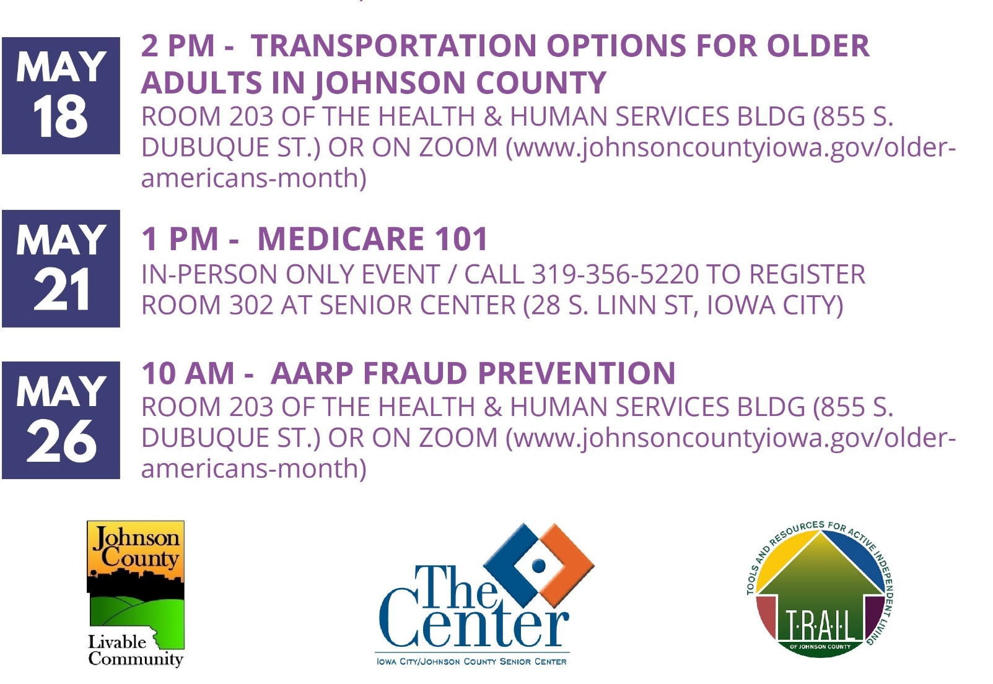
Direct Assistance Program
Johnson County's Direct Assistance Program provides one-time, financial assistance to eligible residents who have suffered hardship due to COVID-19. Applications are currently open and close on Monday, May 23, 2022 at 12 p.m.
Eligible residents who are low- to moderate-income with documented hardship due to COVID-19 are invited to apply for a $1,400 emergency relief payment.
Applicants may apply online between April 25 at 12 p.m. and May 23 at 12 p.m. Because the number of applications may exceed available funds, recipients will be chosen by random selection. Applying for the program does not guarantee that you will receive assistance.
For more information visit: https://www.johnsoncountyiowa.gov/direct-assistance-program
May 13th Application Clinic
Johnson County is offering an in-person clinic to help residents complete applications on Friday, May 13 from 12 p.m. to 6 p.m. in room 203B/C at the Johnson County Health and Human Services Building, 855 S. Dubuque Street Iowa City. We encourage residents to make an appointment using the following link: https://calendly.com/direct-assistance-program/direct-assistance-program-application-clinic
Residents may also schedule an appointment by calling the clinic hotline between the hours of 9 a.m. and 1 p.m. at 319-688-5988.
Primary Election Information
The Primary Election will be held on Tuesday, June 7th – and the Johnson County Auditor’s Office has plenty of ways for you to vote!
- Early voting by mail: You can request a ballot to be mailed to you by submitting an Absentee Ballot Request form. These forms are available on our website, or you can call our office and ask us to mail you a form. We cannot accept ballot requests via phone or email. We must have the Absentee Ballot Request forms in our office by 5pm on Monday, May 23. You can mail or deliver them to our office at 913 S. Dubuque St. (full contact information below).
- Early voting in person:
  - Voting at our office (913 S. Dubuque St.) and drive-thru voting (855 S. Dubuque St.) will start at 8am on Wednesday, May 18th. Hours are 8am – 5pm Monday through Friday, with weekend hours of 9am-5pm on Saturday, June 4thand 10am-4pm on Sunday, June 5th.
  - All Johnson County voters can cast their ballot at the following satellite locations.
    - Coralville Public Library, 1401 5th St., Coralville, Saturday, June 4, 10am-4pm
    - North Liberty Community Library, 520 W. Cherry St., North Liberty, Saturday, June 4, 11am-5pm
    - Dream City (formerly Kingdom Center), 611 Southgate Ave., Iowa City, Sunday, June 5, 9am-3pm
    - Iowa City Public Library, 123 S. Linn St., Iowa City, Sunday, June 5, 11am-5pm
- Election Day: Polls are open from 7am-8pm. Heads up – you might have a new polling place! Due to the reprecincting process after the 2020 census, you may reside in a new precinct or have a new polling place. Our office will mail out notices to every registered voter, but you can always confirm your polling place using our online locator.
APPLY TO BE A PRECINCT ELECTION OFFICIAL
Join the teams that make our elections possible! Earn $16.25/hr, plus overtime and mileage.
Requirements:
- Registered to vote in Johnson County
- Able to provide your own transportation to and from the polls
- Willing to work long hours (typically 6am-10pm)
- Willing to attend paid training prior to working an election
We are especially in need of PEOs that are registered Republican or No Party voters
For more information or to apply, visit: www.johnsoncountyiowa.gov/peo
Our website has more information, including sample ballots and candidate information. Please contact our office with any questions. We are here to help!
Johnson County Auditor
913 S Dubuque St #101
Iowa City, IA 52240
bit.ly/22primary
(319) 356-6004
elections@johnsoncountyiowa.gov

Senior Farmer's Market Nutrition Program
The Senior Farmer’s Market Nutrition Program is sponsored through the US Department of Agriculture and administered through the Heritage Area Agency on Aging. Qualified seniors will receive $30 worth of checks to use at participating area farmers’ markets vendors per year.
Eligibility Requirements:
- At least 60 years of age
- Live in Johnson County or the service area of the Heritage Area Agency on Aging
- For Single Person: Annual income of less than $25,142
- For Married Couple: Annual income of less than $33,874
Distribution will be available in Room 202 of the Health and Human Services Building, 855 S. Dubuque Street, Iowa City, IA 52240 at the following dates and times:
- Wednesday, June 1st 1-3PM
- Thursday, June 9th 2-3PM
If unable to attend either of these times or if you have questions contact Jeff Kellbach at 319-688-5842 or by email at jkellbach@johnsoncountyiowa.gov

Farmer’s Markets
Below is a list of Farmer's Markets occurring in Johnson County that have finalized their 2022 schedule.
- Iowa City Farmer’s Market - https://www.icgov.org/farmersmarket
415 E. Washington St. Iowa City, IA 52240
May – October Saturdays, 7:30 am – 12 pm
- Coralville Farmer’s Market - https://iowariverlanding.com/event/2022-coralville-farmers-market/all/?eventDisplay=past
Iowa River Landing (South of the Staybridge hotel located at 801 E. 2nd Ave., Coralville, IA 52241)
May 18 – October 5 – Wednesdays from 4:30 – 6:30 pm
- Solon Farmer's Market- https://www.facebook.com/Solonmarket/
Mushroom Parking Lot
June 7- Tuesdays from 3-6PM
- University Heights Farmer’s Market
Courtyard Marriott, 901 Melrose Avenue, Iowa City, IA 52240
June 7- Tuesdays from 4-6PM
- Field to Family Online Farmer’s Market - https://fieldtofamily.org/online-farmers-market/
Order online between Monday at 8AM to Tuesday at Noon for Thursday pickup or delivery.

Dementia Friendly Community
Would you like to help Johnson County become a Dementia Friendly Community? We are looking for people to join our Action Team. Our first meeting is scheduled for Tuesday, May 24th at 3PM via Zoom. Feel free to reach out to Jeff Kellbach at 319-688-5842 or by email at jkellbach@ohnsoncountyiowa.gov with any questions or more information.
https://us02web.zoom.us/j/83256506846
Meeting ID: 832 5650 6846
What is a Dementia Friendly Community?
Dementia Friendly America (DFA) is a national network of communities, organizations and individuals seeking to ensure that communities across the U.S. are equipped to support people living with dementia and their caregivers. Dementia Friendly Iowa is the initiative at the state level helping launch individual dementia friendly communities across the state. A dementia friendly community is a village, town, city or county that is informed, safe and respectful of individuals with the disease, their families and caregivers and provides supportive options that foster quality of life. Becoming a recognized Dementia Friendly Community means a community is engaging in a process to become more dementia friendly.
More information can be found at https://dementiafriendlyiowa.org/
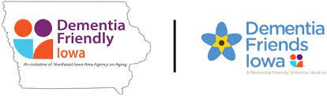
REAL ID
A reminder that the United States Department of Homeland Security will begin enforcing the REAL ID law until May 3, 2023.
If you fly commercially you will either need a REAL ID (Gold Star) license or another acceptable document, or you're going to be subject to additional screening and potential delay.

WHAT IS THE REAL ID ACT?
REAL ID is a federal act focusing on anti-terrorism, fraud protection, and security specific to the production of driver's licenses and ID cards that control access to
-Federal facilities requiring identification to enter.
-Federally regulated commercial aircraft.
-Nuclear power facilities.
Find out more about the REAL ID Act.

DO I NEED A REAL ID LICENSE OR ID?
REAL ID does not:
-invalidate your state issued driver’s license or ID card.
-Affect using a driver’s license or ID card for usual purposes, such as driving, renting a vehicle, writing a check, purchasing alcohol or tobacco, or entering a casino.
You may not need a REAL ID compliant license or ID card if you
-Do not fly and do not plan to enter certain federal facilities, such as military bases and nuclear power plants.
-Have an acceptable alternative to a state-issued REAL ID compliant driver’s license or ID card, such as a valid U.S. passport.

HOW DO I GET A REAL ID-COMPLIANT CARD?
- If you decide you need a REAL ID license or ID, you can get one at any time. If your license or ID will expire before May 3, 2023, you can just wait until it’s time to renew and do it then. If you your license or ID will expire on or after May 3, 2023, you can come in to one of our driver’s license service centers (REAL ID not available on online renewal or kiosk) before then and get a replacement license or ID that’s marked as a REAL ID license or ID.
- Getting a REAL ID license or ID is just like getting your license or ID for the first time. To meet the federal requirements, you will have to bring documents that prove your identity and date of birth, social security number, and Iowa residence and residential address.
- It doesn’t cost more to get a REAL ID license or ID. If you’re renewing your license or ID, the renewal fee is the same. If you’re getting a replacement, the replacement fee is the same $10 required for any replacement or duplicate license or ID.
- There are no tests or driving requirements to get a REAL ID license. The federal REAL ID regulations only require that you re-provide your identity, not your driving knowledge or ability. If you already have a driver’s license, you don’t have to take written or driving tests just to add the REAL ID star.
- You only have to go through the REAL ID process one time. Once we verify your identity and add the REAL ID star, you don’t have to re-apply when you renew your license in the future – we will continue to apply the REAL Id star whenever you renew your license.
Click here for more information about the Real ID.

Johnson County Caregiver Event
Powerful Tools for Caregivers
Local Programming & News
AARP Iowa- Upcoming Events
Alzheimer's Association- Upcoming Events and Support Groups
COVID Recovery Iowa- Facebook Group Silver Linings
Hancher Auditorium- Upcoming Events
Iowa City Senior Center- May and June Program Guide
North Liberty Senior 55+ Connections Lunch- In-person lunches and programming- Click here for the calendar. Call (319) 626-5701 or email agolly@northlibertyiowa.org
Stanley Museum of Art- Click here for their website.
Solon Senior News- Click here for their May Newsletter
TRAIL of Johnson County- Their calendar features a curated collection of virtual public events (as well as those just for TRAIL members) that they select from local, regional, and national sources. That link is here: https://trailofjohnsoncounty.org/calendar

*THE JOHNSON COUNTY LIVABLE COMMUNITY NEWSLETTER IS A DIGITAL NEWSLETTER- THIS HAS BEEN CONVERTED TO A PRINTABLE FORMAT FOR ALL TO READ. PLEASE NOTE THAT MANY OF THE CLICKABLE LINKS WILL ONLY WORK WHEN VIEWED THROUGH A DIGITAL DEVICE.
TO SUBSCRIBE TO THE MONTHLY JOHNSON COUNTY LIVABLE COMMUNITY NEWSLETTER YOU MAY VISIT https://livablecommunity.us3.list-manage.com/subscribe?u=a9f307a3cbce1cc4ca622bb7f&id=d21460a2e3 or contact Jeff Kellbach at 319-688-5842 or by email at jkellbach@johnsoncountyiowa.gov

