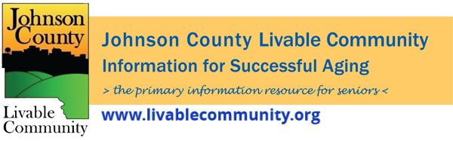

February 2022 Newsletter
In this month's issue:
- Ageless: The New Science of Getting Older Without Getting Old
- Rapid At-Home Tests
- Free Tax Preparation Services
- Black History Month
- Iowa Rent Reimbursement
- Iowa Property Tax Credit Claim
- Affordable Connectivity Program
- Earn- N- Learn Workshops
- Tai Chi for Arthritis
- Powerful Tools for Caregivers
- Local Programming and News
Ageless: The New Science of Getting Older Without Getting Old
Monday, February 7, 1:00-2:00 pm
Location: Meets on Zoom
Register online or call 319-356-5220
Prairie Lights, the Senior Center, and TRAIL of Johnson County are excited to present a reading and book discussion with Andrew Steele, author of Ageless: The New Science of Getting Older Without Getting Old. In his book, Steele presents the scientific factors that contribute to aging in a way that is easy to understand while also providing practical advice to live a longer, healthier life. The program will begin with Steele reading a short section of his book, followed by an interactive discussion. Bring your comments and questions.
Free At-Home Rapid COVID-19 Tests
Every home in the US is eligible to order 4 free at-home COVID-19 tests by going to https://www.covidtests.gov/
The tests available for order:
- Are rapid antigen at-home tests, not PCR
- Can be taken anywhere
- Give results within 30 minutes (no lab drop-off required)
- Work whether or not you have COVID-⁠19 symptoms
- Work whether or not you are up to date on your COVID-⁠19 vaccines
- Are also referred to self-tests or over-the-counter (OTC) tests
There are other test options available in the community which include:
- Contact your healthcare provider
- Nomi Health- https://mdc.nomihealth.com/easy_registration/175/onsite
- Mercy Iowa City- https://www.mercyiowacity.org
- Test Iowa- https://www.testiowa.com/en
- University of Iowa Hospitals and Clinics- https://uihc.org/testing-covid-19-or-respiratory-symptoms
*The CDC is encouraging everyone 12 and older to be up to date on their COVID-19 vaccine recommendations, which means to be fully vaccinated and boosted when eligible. To find out if you're eligible, visit: https://www.cdc.gov/coronavirus/2019-ncov/vaccines/stay-up-to-date.html
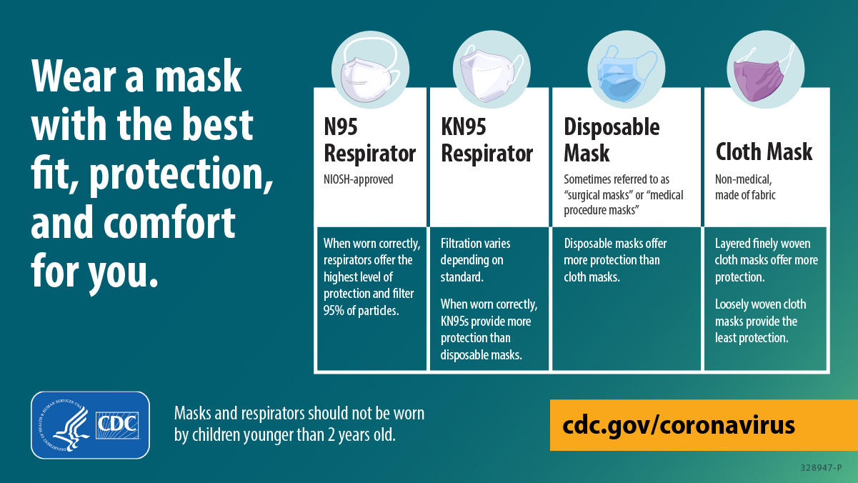
Free Tax Preparation Services
It’s tax season again! We know filing taxes can be long, and confusing which is why we have some resources that can help – for FREE. Here are the details for two different services.
AARP Foundation Tax Aide
Free tax preparation services will be offered by appointment at the Senior Center in February-April 2022. Low to moderate income taxpayers, especially those age 60+, can receive this free service, provided by trained volunteers through a partnership with the AARP Foundation Tax-Aide Program. Click here to schedule an intake appointment.
For health and safety, this year's tax appointments will be provided with minimal contact:
- Clients will schedule an intake appointment to drop off and inventory their tax-related materials and sign a couple forms.
- A counselor will prepare the tax return while the client waits; the counselor will consult the client with any questions.
- The counselor will review the completed return with the client before e-filing; clients should expect the process to take approximately 60-90 minutes.
To have taxes prepared, clients must bring:
- Copies of the last two years of federal and state tax returns filed
- Photo ID and Social Security card for each taxpayer included on the return
- Bank routing/account number for direct deposit/debit
- W-2 forms, 1099 forms, other statements of income
- If applicable, additional documentation detailing itemized deductions and credits/adjustments
- 1095-A forms if you purchased insurance through the Marketplace (Exchange)
- For more details on important documents, visit https://www.aarp.org/money/taxes/info-01-2011/important-tax-documents.html
VITA Tax Clinic:
The IRS Volunteer Income Tax Assistance (VITA) Program is offering free tax help to people who need assistance in preparing their tax return. Help is available to the following individuals:
- People who generally make $57,000 OR LESS
- Persons with disabilities
- Limited English speaking taxpayers
Due to COVID, VITA will be using mostly contact-less delivery options.
To get started email, Vita@uiowa.edu, call 319-335-0857 or click here.
After completing the form in this link, the VITA intake forms will be sent to you.
Black History Month
February is Black History Month and the City of Iowa City wants to celebrate by hosting and co-hosting some events. These events will range from presentations, book club discussions, movie screenings, dance workshops, trivia and much more. These informational activities are meant to highlight the impacts Black Americans have had, and have, on our country while recognizing the barriers and injustices Black Americans face today.
Black History calendars are available to learn about Black History all year long! These calendars are available at The Office of Equity and Human Rights from 8am-noon and then 1-5 Monday through Friday at on the third floor of City Hall, 410 E. Washington Street.
Here is a list of all of the Black History month activities:
- Afro-Cuban Dance Workshop with Modei Akyea
- Black History calendar creation studio
- Black History Month trivia night
- Book club discussion of Jason Mott’s “Hell of a Book”
- Superheroes of Science for Pre-K through 2nd Grade
- Black History storytime
- Presentation on the Tuskegee Airmen
- Screening of “My Name Is Pauli Murray” documentary
- Presentation on “The Only One” by the African American Museum of Iowa
For more details and to register, visit this website - icgov.org/BHM2022

Iowa Rent Reimbursement
You can file for 2021 Iowa Rent Reimbursement if you meet all of the following requirements:
- You were 65 years of age or older, or disabled and 18 or older
- Your income was less than $24,354
- You lived in Iowa and still live in Iowa now
- You paid rent in Iowa at a property that pays property tax
2020 Iowa Rent Reimbursement claims can be filed until December 31, 2022. 2020 Rent Claim Form
2021 Iowa Rent Reimbursement claims can be filed until December 31, 2023. 2021 Rent Claim Form
Click here for more information and commonly asked questions about the program.

Iowa Property Tax Credit Claim Form (Elderly and Disabled Tax Credit)
Property tax credit is for Iowa resident homeowners who are eligible to file a claim for assistance towards property tax if the applicant meets age/disability and household income requirements.
If you meet the following requirements, you may be eligible for a property tax credit.
- Iowa residents
- Total household income less than $24,354 and age 65 or older on December 31, 2021, or
- Total household income less than 250% of the federal poverty level and age 70 or older on December 31, 2021, or
- Totally disabled and age 18 or older by December 31, 2021
2022 Iowa Tax Credit Claim Form (Elderly & Disabled Tax Credit)
Return forms to Johnson County Treasurer's Office, 913 S. Dubuque St., Iowa City, IA 52240

Affordable Connectivity Program
The Affordable Connectivity Program (ACP) is a program that aims to ensure that households will be able to afford and receive the broadband network they need for school, work, healthcare, and entertainment. The maximum monthly benefit available for eligible households is $30 towards internet service ($75 for households on qualifying Tribal lands). Households can receive a one-time discount of up to $100 to purchase a laptop, desktop computer, or tablet if they contribute more than $10 but less than $50 toward the purchase price. You can receive the Affordable Connectivity Program at the same time as the Federal Communication Commission’s Lifeline program. You are only allowed to receive one ACP benefit per household, not per person.
Who Is Eligible for the Affordable Connectivity Program? (Affordable Connectivity Program | Federal Communications Commission (fcc.gov))
A household is eligible if a member of the household meets at least one of the criteria below:
- Has an income that is at or below 200% of the federal poverty guidelines ($27,180 annual income); or
- Participates in certain assistance programs, such as SNAP, Medicaid, Federal Public Housing Assistance, SSI, WIC, or Lifeline;
- Participates in Tribal specific programs, such as Bureau of Indian Affairs General Assistance, Tribal TANF, or Food Distribution Program on Indian Reservations;
- Is approved to receive benefits under the free and reduced-price school lunch program or the school breakfast program, including through the USDA Community Eligibility Provision in the 2019-2020, 2020-2021, or 2021-2022 school year;
- Received a Federal Pell Grant during the current award year; or
- Meets the eligibility criteria for a participating provider's existing low-income program.
Which Iowa providers are participating in the Affordable Connectivity Program? Affordable Connectivity Program Providers | Federal Communications Commission (fcc.gov)
How to apply:
Households can enroll by visiting https://acpbenefit.org/
AFTER APPLYING: Contact preferred participating provider to select a plan (some providers may have an alternative application they will ask you to complete as well as this one).
Documentation needed:
- Benefit award letter for qualifying programs (ex. SNAP).
- Prior tax return OR current income statement OR Social Security benefits letter
- Valid ID OR Birth Certificate OR Driver’s License OR passport OR Green Card OR Certificate of U.S. Citizenship or Naturalization
- ID OR utility bill OR mortgage/lease statement
Qualifying Tribal lands: (Enhanced Tribal Benefit - ACP - Universal Service Administrative Company (acpbenefit.org))
- Any federally recognized Indian Tribe’s reservation, pueblo, or colony,
- Former reservations in Oklahoma,
- Alaska Native regions establishes pursuant to the Alaska Native Claims Settlement Act,
- Indian allotments,
- Hawaiian Home Lands, and
- Any land approved as Tribal for the purposes of the Lifeline program or the EDD Program by the FCC’s Office of Native affairs and Policy on Wireline Competition Bureau.

Horizons Financial Wellness Center Earn-N-Learn Workshops
The Financial Wellness Center Earn-N-Learn Workshops cover Credit, Savings and Debt Management. This interactive presentation allows attendees to identify financial goals, discuss strategies to reduce expenses, plan for next steps, and plan for setbacks and set reminders for upcoming steps.
Each household that completes all 3 session in the quarter will receive $50. They can potentially earn an additional $30 by completing follow-up surveys!
Sign up online at https://horizonsfamily.org/fwcnews/
There will be a Zoom session as well as an in-person session held at the Health and Human Services Building, 855 S. Dubuque Street, Meeting Room 203, Iowa City, Iowa 52240.
In-Person at the Health and Human Services Building, Room 203 will meet on:
-Thursday, April 21 at 1PM- Credit Voyage
-Thursday, May 19 at 1PM- Savings Success
-Thursday, June 16 at 1PM- Debt Management
Zoom- Thursdays at 12PM on:
-April 14- Credit Voyage
-May 12- Savings Success
-June 9- Debt Management

Tai Chi for Arthritis & Fall Prevention
Taught by Certified TCA Instructors: https://ezregister.com/events/35897/ (via Zoom)
- This program is for anyone 65 or older or anyone with a chronic health condition.
- Tai Chi has a registration fee of $40 per person.
- To enroll in this class you MUST be able to stand on one leg (on each of your legs) for 5 seconds – call Kathy Lee at Office: 319-384-5681 or Cell: 563-340-8242 if you are unsure of how to test yourself – It’s easier than it sounds!
Classes are from 10 AM to 11:30 AM on the following dates:
March 16th and 18th
March 23rd and 25th
March 30th and April 1st
April 6th and 8th
April 20th and 22nd
April 27th and 29th
May 4th and 6th
Powerful Tools for Caregivers
Click here or the image below for more information.
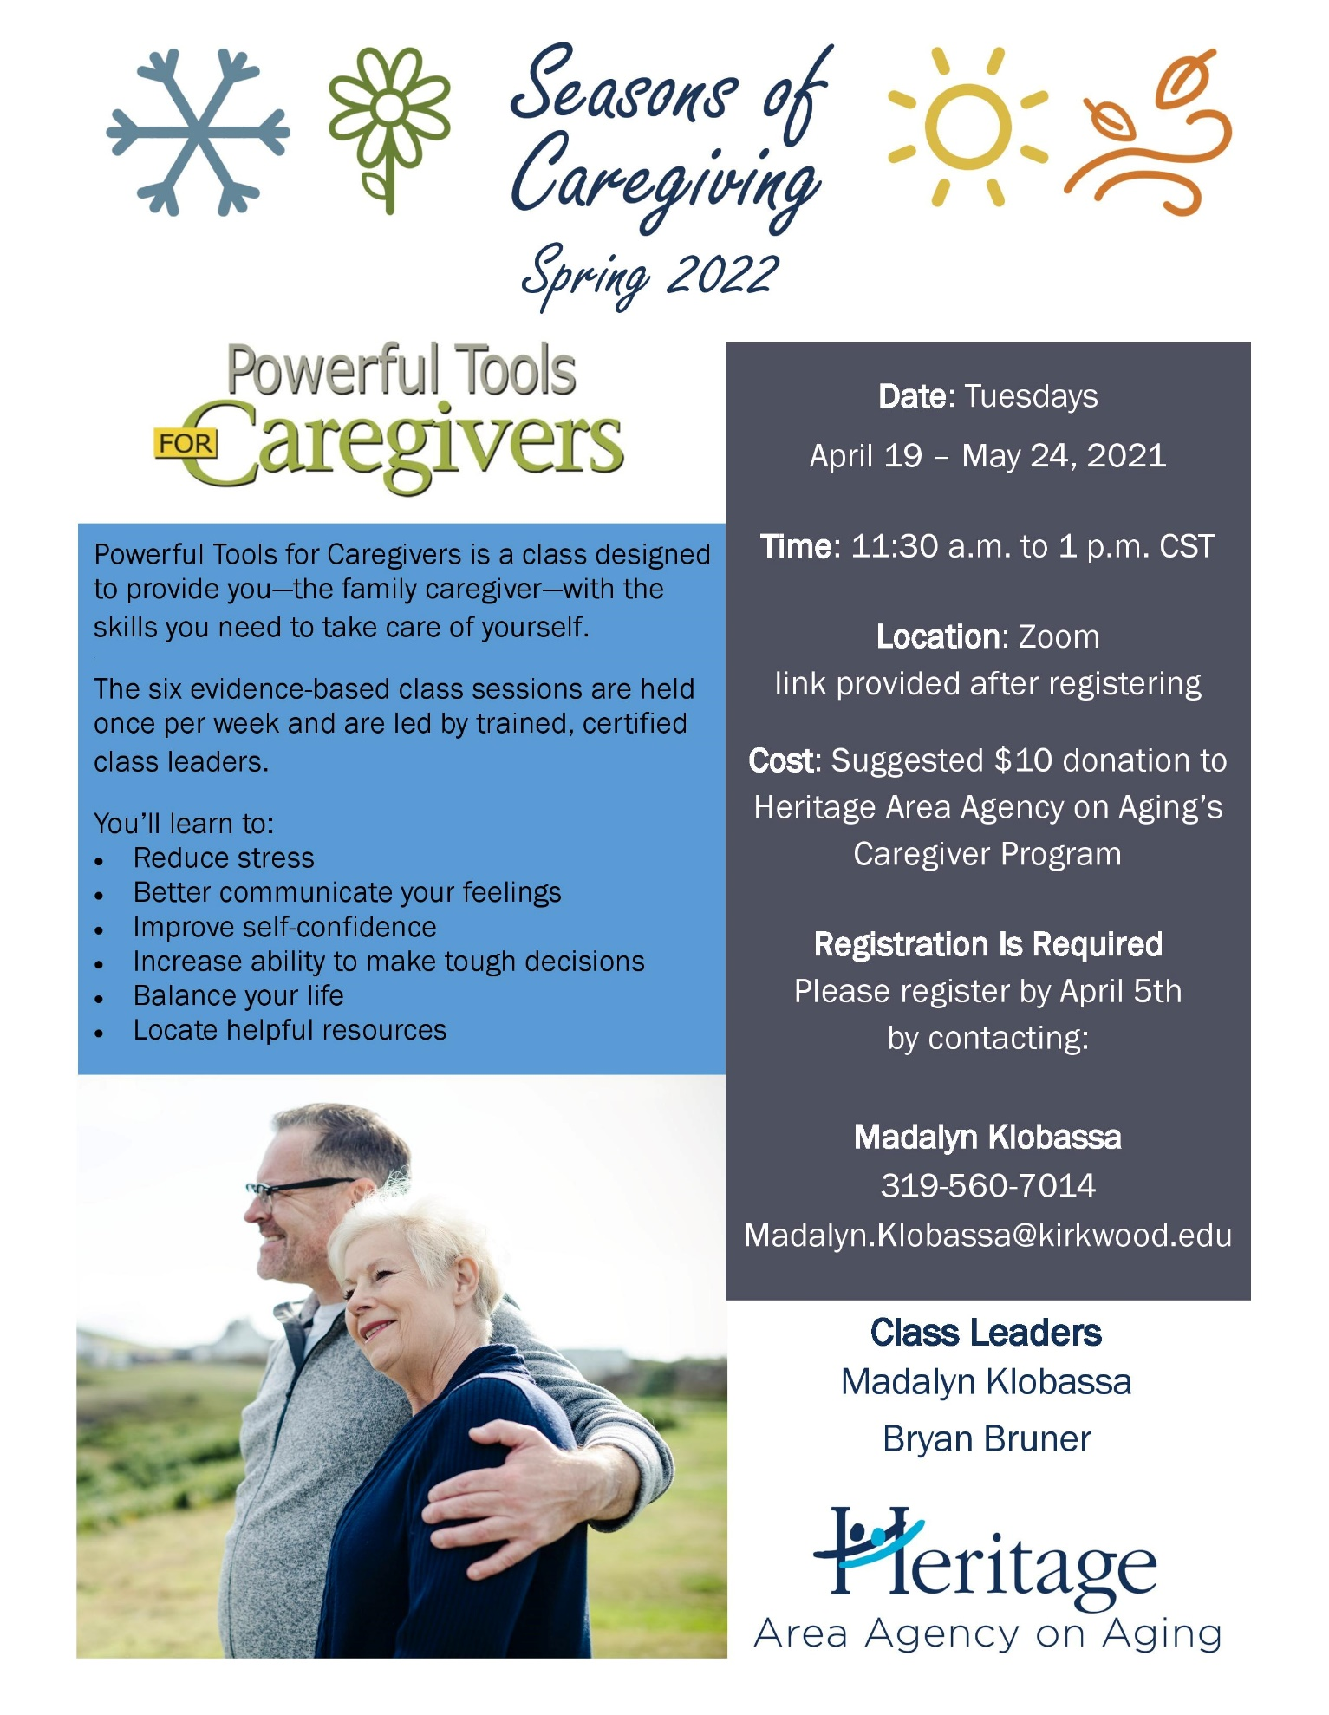

Local Programming & News
AARP Iowa- Upcoming Events
Alzheimer's Association- Upcoming Events and Support Groups
COVID Recovery Iowa- Facebook Group Silver Linings
Hancher Auditorium- Upcoming Events
Iowa City Senior Center- January and February Program Guide
North Liberty Senior 55+ Connections Lunch- In-person lunches and programming- Click here for the calendar. Call (319) 626-5701 or email agolly@northlibertyiowa.org
Stanley Museum of Art- Click here for their website.
Solon Senior News- Click here for their February Newsletter
TRAIL of Johnson County- Their calendar features a curated collection of virtual public events (as well as those just for TRAIL members) that they select from local, regional, and national sources. That link is here: https://trailofjohnsoncounty.org/calendar
UI Center for Human Rights- Upcoming Events

*THE JOHNSON COUNTY LIVABLE COMMUNITY NEWSLETTER IS A DIGITAL NEWSLETTER- THIS HAS BEEN CONVERTED TO A PRINTABLE FORMAT FOR ALL TO READ. PLEASE NOTE THAT MANY OF THE CLICKABLE LINKS WILL ONLY WORK WHEN VIEWED THROUGH A DIGITAL DEVICE.
TO SUBSCRIBE TO THE MONTHLY JOHNSON COUNTY LIVABLE COMMUNITY NEWSLETTER YOU MAY VISIT https://livablecommunity.us3.list-manage.com/subscribe?u=a9f307a3cbce1cc4ca622bb7f&id=d21460a2e3 or contact Jeff Kellbach at 319-688-5842 or by email at jkellbach@johnsoncountyiowa.gov

