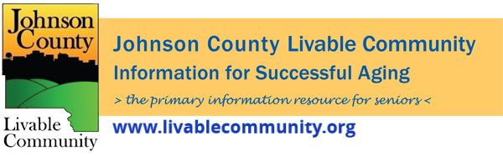

January 2022 Newsletter
In this month's issue:
- Isolation and Quarantine Recommendations
- MLK Day Activities
- Johnson County Caregiving Event
- Alzheimer's Association Winter Program Series
- Energy and Water Assistance
- Local and Virtual Programming
Updated Isolation and Quarantine Recommendations
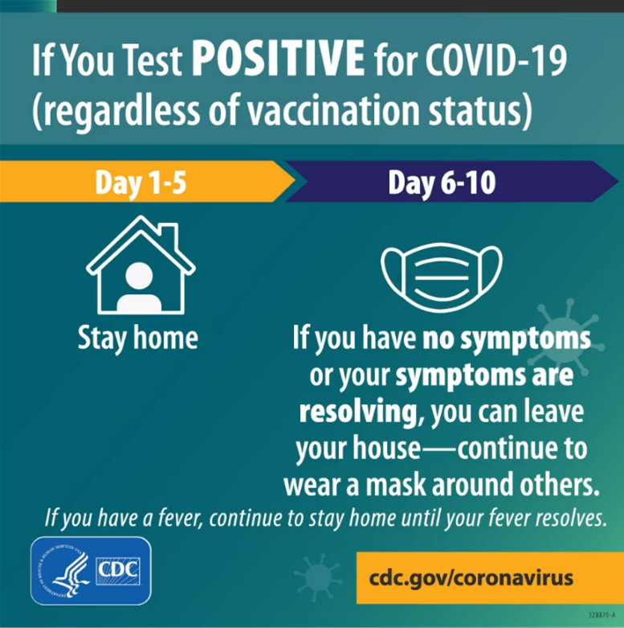 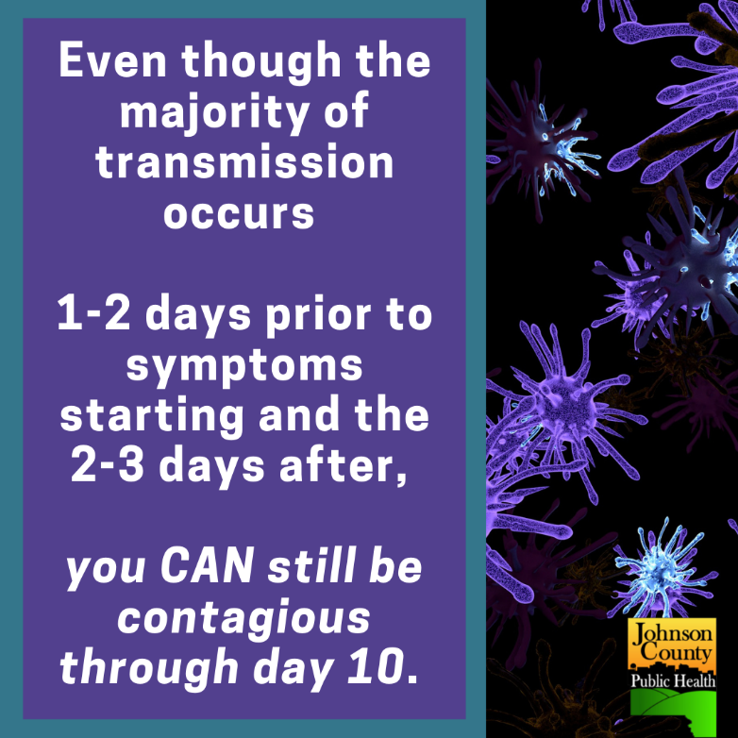
For the most up to date information go to https://www.johnsoncountyiowa.gov/department-of-public-health

MLK Day Activities
The City of Iowa City, Iowa City Public Library and the University of Iowa are hosting multiple events for Martin Luther King Jr. Day. You can find details at https://www.icgov.org/martin-luther-king-jr-day-2022.

Johnson County Caregiving Event
Alzheimer's Association Winter Program Series
The Alzheimer's Association will have a Winter Program Series for Caregivers. Please note there are updated dates from last month's newsletter for the Legal and Financial as well as the New Advancements in Alzheimer's Treatment programs. See the flyer below for additional information about the virtual programs. To register for the programs please call 800-272-3900 or click here.

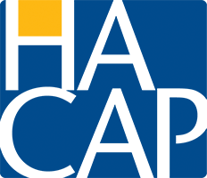
Energy and Water Assistance
The Low-Income Home Energy Assistance Program (LIHEAP) and Low-Income Household Water Assistance (LIHWAP) is designed to help low-income individuals and families meet the cost of home heating and water. Applications are currently being accepted for persons over the age of 60 and/ or disabled. Applications are open for everyone else on November 1st and will be accepted through April 30, 2021.
For more information or to apply online visit: https://www.hacap.org/energy
Printable applications can be downloaded here.
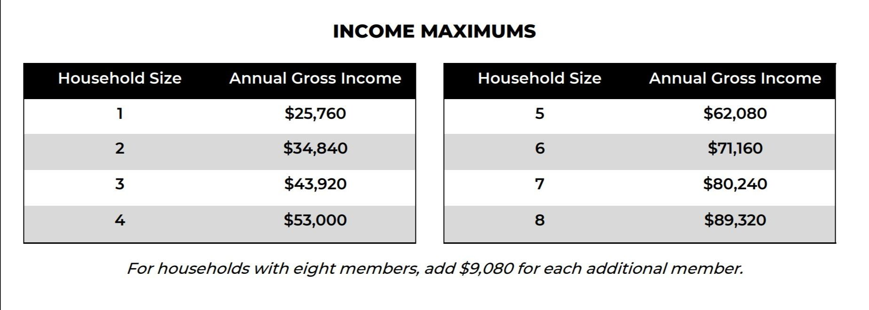

Local Programming & News
Alzheimer's Association- Upcoming Events
COVID Recovery Iowa- Facebook Group Silver Linings
Hancher Auditorium- Upcoming Events
Iowa City Senior Center- January and February Program Guide
North Liberty Senior 55+ Connections Lunch- In-person lunches and programming- Click here for the calendar. Call (319) 626-5701 or email agolly@northlibertyiowa.org
Stanley Museum of Art- Click here for their website.
Solon Senior News- Click here for their January Newsletter
TRAIL of Johnson County- Their calendar features a curated collection of virtual public events (as well as those just for TRAIL members) that they select from local, regional, and national sources. That link is here: https://trailofjohnsoncounty.org/calendar
UI Center for Human Rights- Upcoming Events including the January 21st program entitled MLK's Dream. Living our Values.

*THE JOHNSON COUNTY LIVABLE COMMUNITY NEWSLETTER IS A DIGITAL NEWSLETTER- THIS HAS BEEN CONVERTED TO A PRINTABLE FORMAT FOR ALL TO READ. PLEASE NOTE THAT MANY OF THE CLICKABLE LINKS WILL ONLY WORK WHEN VIEWED THROUGH A DIGITAL DEVICE.
TO SUBSCRIBE TO THE MONTHLY JOHNSON COUNTY LIVABLE COMMUNITY NEWSLETTER YOU MAY VISIT https://livablecommunity.us3.list-manage.com/subscribe?u=a9f307a3cbce1cc4ca622bb7f&id=d21460a2e3 or contact Jeff Kellbach at 319-688-5842 or by email at jkellbach@johnsoncountyiowa.gov

