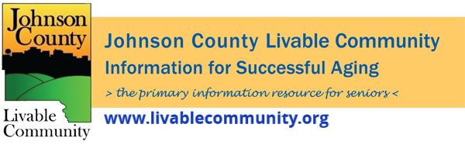

December 2021 Newsletter
In this month's issue:
- COVID Booster
- Free Counseling Services
- COVID Recovery Iowa Older Adults Services
- hoopla: New Streaming Service
- Alzheimer's Association Winter Programming
- Snow Removal Sign-Up
- Energy and Water Assistance
- Virtual Programming
Booster doses
Johnson County Public Health encourages everyone aged 18 and over to get boosted!
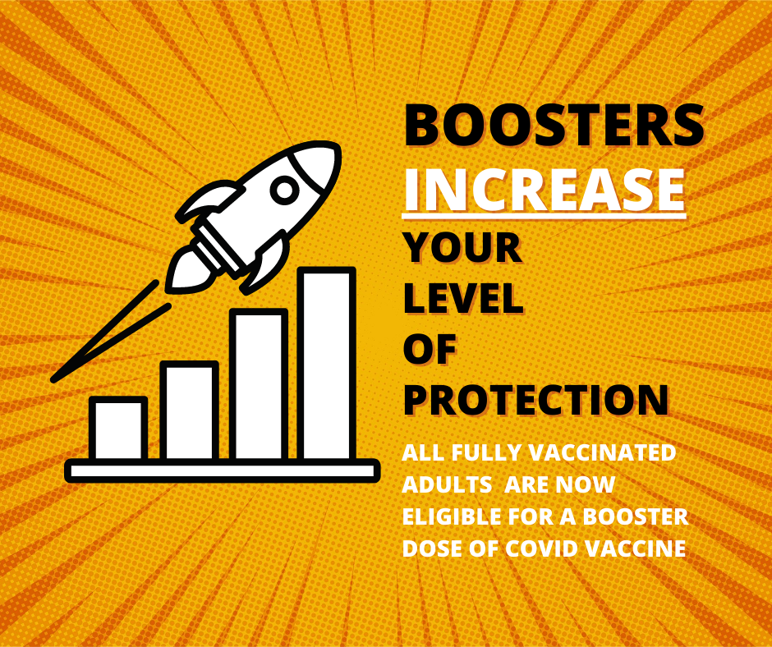

Free Counseling Services
The state of Iowa has received federal funding to offer free virtual counseling and assistance to Iowans of all ages.
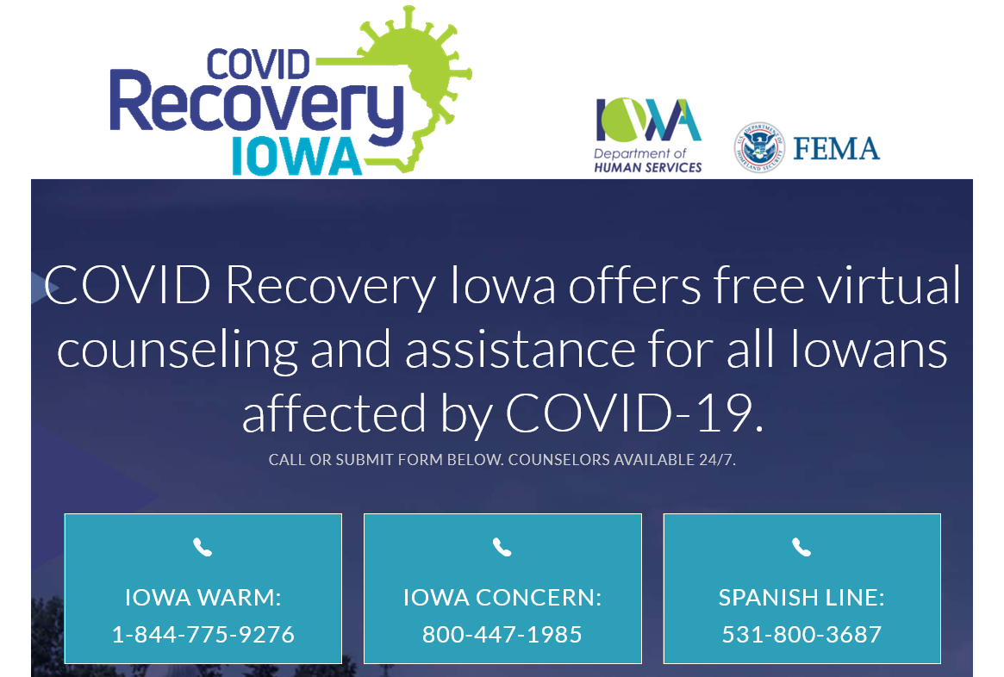
Iowa Warm Line 1-844-775-9276 https://dhs.iowa.gov/mhds/crisis-services
The warm Line is a 24/7 peer run, telephone based non-crisis confidential listening line for anyone struggling with mental health abuse issues. The line is staffed by people who have been through a similar journey and are in recovery themselves.
Iowa Concern 1-800-447-1985 https://www.extension.iastate.edu/iowaconcern/about
Iowa Concern is a program of the Iowa State University Extension and Outreach which serves both urban and rural Iowans. Services are available 24 hours a day, 7 days per week at no charge. Iowa Concern has access to an attorney for legal education, stress counselors, and information and referral services for a wide variety of topics.
Iowa Spanish Helpline 515-344-3936
https://humanrights.iowa.gov/l%C3%ADnea-de-ayuda-en-iowa
This line is to help the Spanish-speaking community in the state of Iowa with the goal of providing information, resources and support for the Iowa community. The line is answered by professionals from the Latino community. All the information is confidential. Hours of operation: Monday-Friday 8AM-5PM.
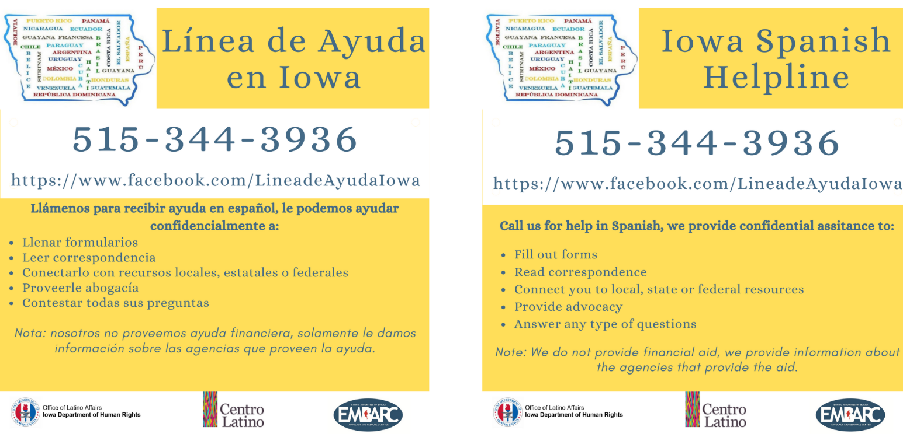
COVID Recovery Iowa Older Adult Services
The state of Iowa has received federal funding to offer free programming for Older Adults.
- Social Check-ins & Coffee Chats: COVID Recovery Iowa counselors can provide check-in calls, texts and emails as a way to touch base each week.
- Music Services: A COVID Recovery Iowa counselor can arrange a variety of personalized musical telegrams, sing-a-longs or mini concerts.
- Life Stories: Talk to one of our COVID Recovery Iowa counselors and share your life story and special memories. This can be written as your legacy for you to share.
- Tech and Media Assistance: Life Stories: COVID Recovery Iowa counselors can walk you through using Zoom, tech services, software and apps if you want to participate in COVID Recovery Iowa's programs on Facebook. Counselors help brainstorm ways to utilize technology to better connect with friends, family, and community.
- Caregiver Support Group: You may be caring for a relative, friend, community member, or spouse. Your wellbeing is important, too! Join on Wednesday evenings for a caregiver support group. We'll talk about managing caregiver stress to avoid burnout in this safe, secure setting.
- Pen Pal Program: Write letters with one of the COVID Recovery Iowa staff.
Call 800-447-1985 to speak with a COVID Recovery Iowa Counselor 24 hours a day/ 7 days a week or go to https://covidrecoveryiowa.org/ or visit the Covid Recovery Iowa Facebook page.

hoopla: New Streaming Service
Beginning Tuesday, December 7th, hoopla will be available at the Iowa City Public Library.
A digital library collection, hoopla offers over one million titles of movies, music, eBooks, audiobooks, and comics. Find a great selection of holiday movies, ACORN TV, movie soundtracks, science fiction and romance reads, and comics from DC, Marvel, Image, and much, much more. Everything you need to brave a Midwestern winter. Best of all? No holds.
ICPL cardholders that live in Iowa City, Hills, Lone Tree, University Heights, and rural Johnson County can use hoopla by going to hoopladigital.com. To sign up, you’ll need your library card number, the password/pin for your card, and a valid email address. ICCSD students can use hoopla with their AIM card as long as they live in ICPL's service area.
Users can watch, listen, or read up to 8 borrows a month. Apps are available for iOS, Android, and Kindle Fire. hoopla also supports Roku, FireTV, AppleTV, and Chromecast as well as Amazon Alexa for music and audiobooks. Instructions on getting set up are available on the hoopla website. hoopla offers a variety of titles in over 75 different languages including Spanish, French, and Hindi.
Once you borrow a title, you have a specific period of time to watch it. Depending on the format, borrowing periods are:
- Movies and television: 3 days (for TV, you borrow by episode, not season)
- Music: One week (full albums)
- eBooks, audiobooks, and comics: Three weeks
hoopla is powered by donations to the Iowa City Public Library Friends Foundation.
For more information or assistance, give us a call at 319-356-5200 or contact us through email or chat.
Source: https://www.icpl.org/articles/hoopla-new-streaming-service-available-december-7th
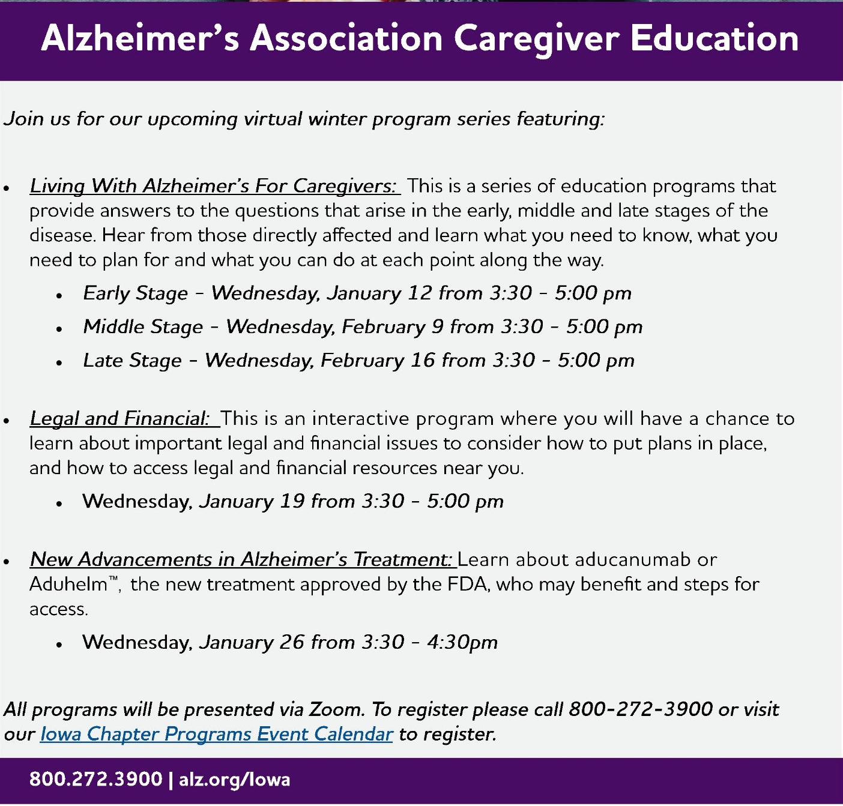
Alzheimer's Association Winter Program Series
The Alzheimer's Association will have a Winter Program Series for Caregivers. See the flyer below for additional information about the virtual programs. To register for the programs please call 800-272-3900 or click here.
Learn more about the Alzheimer's Association and the support they can provide by calling their 24/7 helpline- 800-272-3900 or going to their website- alz.org/iowa
Specific for caregivers - https://www.alz.org/help-support
Specific for those living with dementia - https://www.alz.org/help-support/i-have-alz

Snow Removal Program
Aging Services is expanding its snow removal program in Johnson County by adding additional openings in Iowa City, Coralville and North Liberty. This service, which is very basic, is ideal for those who have physical disabilities, severe arthritis, neuropathy, heart conditions or other risk and cannot afford regular snow removal. For more information, please contact Aging Services at 319-398-3644. Openings are limited.

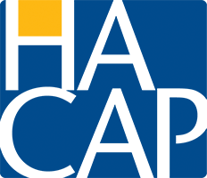
Energy and Water Assistance
The Low-Income Home Energy Assistance Program (LIHEAP) and Low-Income Household Water Assistance (LIHWAP) is designed to help low-income individuals and families meet the cost of home heating and water. Applications are currently being accepted for persons over the age of 60 and/ or disabled. Applications are open for everyone else on November 1st and will be accepted through April 30, 2021.
For more information or to apply online visit: https://www.hacap.org/energy
Printable applications can be downloaded here.
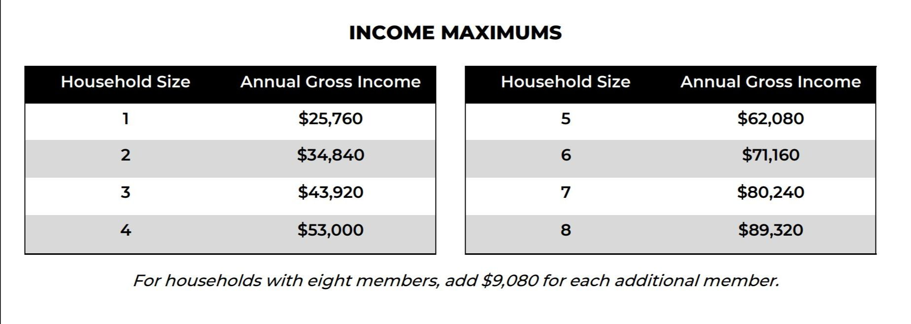

Local Programming & News
Alzheimer's Association- Upcoming Events
AARP Iowa- Upcoming Events
Hancher Auditorium- Upcoming Events
Iowa City Senior Center- November/ December Programs and Updates
North Liberty Senior 55+ Connections Lunch- In-person lunches and programming- Click here for the calendar. Call (319) 626-5701 or email agolly@northlibertyiowa.org
Stanley Museum of Art- Click here for their website.
Local Programming & News Continued
Solon Senior News- Click here for their December Newsletter
TRAIL of Johnson County- Their calendar features a curated collection of virtual public events (as well as those just for TRAIL members) that they select from local, regional, and national sources. That link is here: https://trailofjohnsoncounty.org/calendar
*THE JOHNSON COUNTY LIVABLE COMMUNITY NEWSLETTER IS A DIGITAL NEWSLETTER- THIS HAS BEEN CONVERTED TO A PRINTABLE FORMAT FOR ALL TO READ. PLEASE NOTE THAT MANY OF THE CLICKABLE LINKS WILL ONLY WORK WHEN VIEWED THROUGH A DIGITAL DEVICE.
TO SUBSCRIBE TO THE MONTHLY JOHNSON COUNTY LIVABLE COMMUNITY NEWSLETTER YOU MAY VISIT https://livablecommunity.us3.list-manage.com/subscribe?u=a9f307a3cbce1cc4ca622bb7f&id=d21460a2e3 or contact Jeff Kellbach at jkellbach@johnsoncountyiowa.gov

