October 2021 Newsletter
In this month's issue:
- Holiday Coping Strategies
- 3rd Dose vs Booster
- Election and Early Voting
- Medicare Open Enrollment
- Caregiver Wellness Series
- Snow Removal Sign-Up
- Energy and Water Assistance
- Virtual Programming

Holiday Coping Strategies Virtual Discussion
November 16th, 2021 at 1PM
This has been another tough year for many individuals as we continue to endure through the pandemic and search for a return to some level of pre-pandemic normalcy in our lives. In this session, we will discuss the sense of loss that is facing many of us during this holiday season. The loss can be the result of death, physical distance or social distance.
Mercedes Bern-Klug will facilitate a discussion about how to recognize the sense of loss in ourselves and in others, and consider ways to respond to the loss during the holiday season.
This virtual event is free to attend. You must register in advance at the following link: https://us02web.zoom.us/webinar/register/WN_yNqz5o_gTg6Nin-ch_OUkg
Mercedes Bern-Klug is the Director of the School of Social Work. Her research is in long-term care and advance chronic illness and includes working with family members who share medical decision-making responsibilities with nursing home residents. She is a former Alzheimer support group leader and an Honoring Your Wishes facilitator.
This event is presented by the Johnson County Livable Community Caregiver Action Team.

3rd Dose vs Booster
Confused about whether you need a 3rd Dose or Booster Shot? Check out the difference, and talk to your doctor.
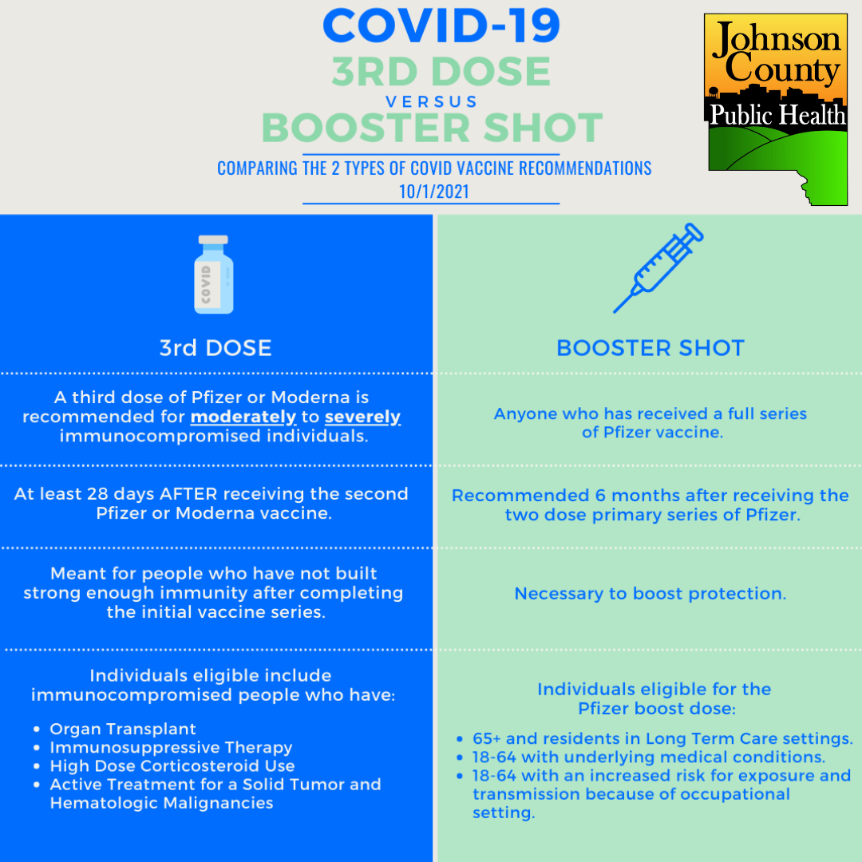
For more information on what qualifies as an underlying medical condition - https://www.cdc.gov/coronavirus/2019-ncov/need-extra-precautions/people-with-medical-conditions.html
For more information on what qualifies as an approved occupational setting - https://www.cdc.gov/coronavirus/2019-ncov/vaccines/booster-shot.html#HighRisk
For the latest information on COVID-19 visit the Johnson County Public Health Coronavirus Information Hub Page

Election and Early Voting
Early voting for the November 2 City and School Election has begun.
Drive through voting is at the parking ramp north of the Johnson County Health and Human Services Building, 855 S. Dubuque St. The entrance to drive up voting will be off Clinton Street. Voting hours will be 8 AM to 5 PM weekdays through Monday, November 1st. Drive through voting will also be available the weekend of 10/30-10/31 from 10AM-4PM.
Voting will also be available at satellite sites. Information on dates, times and locations can be found here. https://www.johnsoncountyiowa.gov/november-2-2021-election-early-voting-schedule
Click here for a list of List of Candidates and Ballot Issues
You can also vote at your polling place on November 2nd from 7AM-8PM. Find your polling place here.

Medicare Open Enrollment
You can enroll in Medicare health and drug plans from October 15 – December 7. Get ready for Medicare’s Open Enrollment with these 5 tips:
- Check your mail. You may get important notices from Medicare or Social Security. If you’re in a Medicare plan, you’ll get an Annual Notice of Changes (ANOC) telling you of any changes in coverage, costs, or service area. Note any 2022 changes to your health coverage or any Extra Help you may get to pay for prescription drugs.
You may also get brochures and other marketing materials from insurance companies that offer Medicare health and prescription drug plans. Remember — plans aren’t allowed to call or come to your home without an invitation from you. Find out how to protect yourself from Medicare fraud.
- Think about your Medicare coverage needs for 2022. Carefully review your current Medicare coverage, and note any upcoming changes to your costs or benefits. Decide if your current Medicare coverage will meet your needs for the year ahead. If you like your current coverage, and it’s still available for 2022, you don’t need to take any action to keep it.
- Review your 2022 “Medicare & You” handbook. It has information about Medicare coverage and Medicare plans in your area. If you want to get your handbook electronically, you can go paperless by logging into (or creating) your secure Medicare account.
- Preview 2022 health and prescription drug plans. We make it easy to compare coverage options and shop for health plans. For a personalized search, log in or create an account (if you have a Medicare Number) to create or access a list of your drugs, compare your current Medicare plan to others, and see prices based on any help you get with drug costs.
- Get personalized help in your community. For local assistance contact a Senior Health Insurance Information Program (SHIIP) counselor. Schedule a telephone or Zoom meeting by contacting the Iowa City Senior Center (319-356-5220) or Mercy Hospital (319-339-3658). You can also schedule appointments online through the Senior Center by clicking here.

Caregiver Wellness Series: Caregiving experiences and strategies to combat social isolation during COVID-19 and Tai Chi demonstration
On November 12th at 1PM the presentation will be on caregiving experiences and strategies to combat social isolation during COVID-19. The presenters will be Kathy Good and Abby Weirather from Family Caregivers Center of Mercy. Bryan Bruner, Heritage Area Agency on Aging will provide a demonstration of Tai Chi for Older Adults.
View it on Zoom or Facebook Live.
Click here to learn more

Snow Removal Program
Aging Services is expanding its snow removal program in Johnson County by adding additional openings in Iowa City, Coralville and North Liberty. This service, which is very basic, is ideal for those who have physical disabilities, severe arthritis, neuropathy, heart conditions or other risk and cannot afford regular snow removal. For more information, please contact Aging Services at 319-398-3644. Openings are limited.

Energy and Water Assistance
The Low-Income Home Energy Assistance Program (LIHEAP) and Low-Income Household Water Assistance (LIHWAP) is designed to help low-income individuals and families meet the cost of home heating and water. Applications are currently being accepted for persons over the age of 60 and/ or disabled. Applications are open for everyone else on November 1st and will be accepted through April 30, 2021.
For more information or to apply online visit: https://www.hacap.org/energy
Printable applications can be downloaded here.
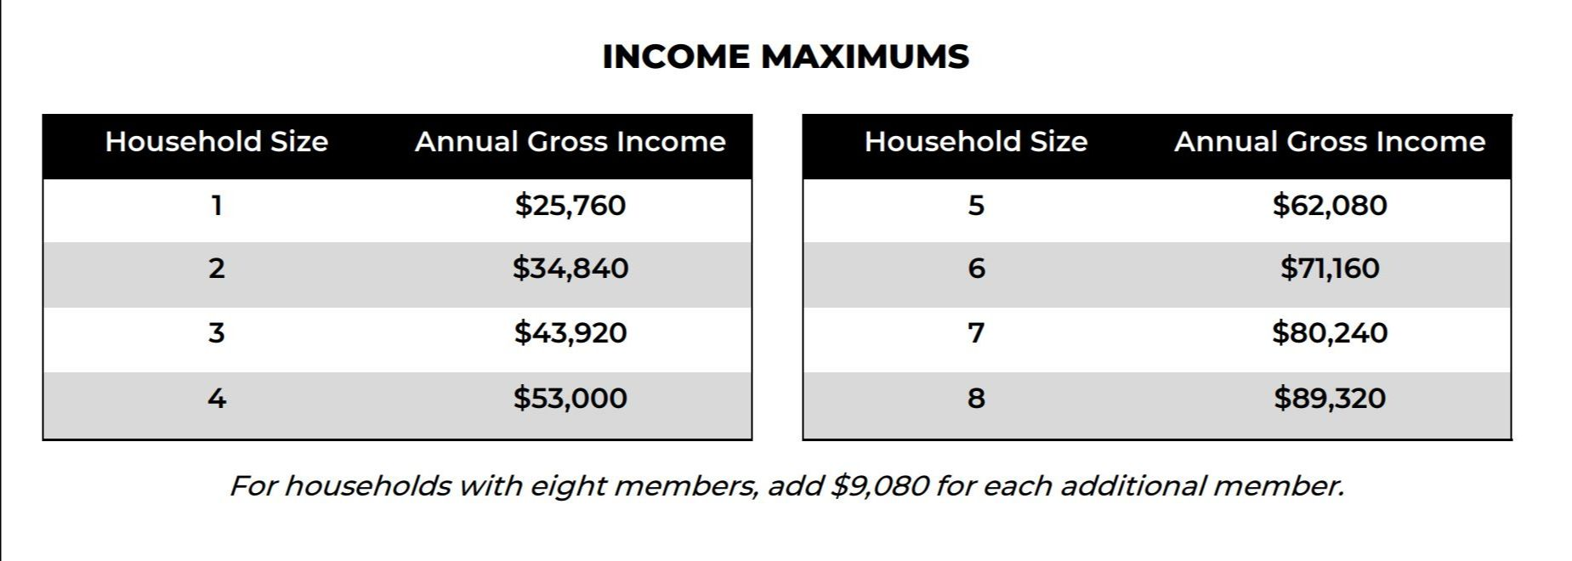

Local Programming & News
AARP Iowa- Upcoming Events
Hancher Auditorium- Upcoming Events
Iowa City Senior Center- October Calendar and Updates
Local Programming & News CONTINUED
North Liberty Senior 55+ Connections Lunch- In-person lunches and programming- Click here for the calendar. Call (319) 626-5701 or email agolly@northlibertyiowa.org
Stanley Museum of Art- Click here for their website.
Solon Senior News- Click here for their October Newsletter
TRAIL of Johnson County- Their calendar features a curated collection of virtual public events (as well as those just for TRAIL members) that they select from local, regional, and national sources. That link is here: https://trailofjohnsoncounty.org/calendar

*THE JOHNSON COUNTY LIVABLE COMMUNITY NEWSLETTER IS A DIGITAL NEWSLETTER- THIS HAS BEEN CONVERTED TO A PRINTABLE FORMAT FOR ALL TO READ. PLEASE NOTE THAT MANY OF THE CLICKABLE LINKS WILL ONLY WORK WHEN VIEWED THROUGH A DIGITAL DEVICE.
TO SUBSCRIBE TO THE MONTHLY JOHNSON COUNTY LIVABLE COMMUNITY NEWSLETTER YOU MAY VISIT https://livablecommunity.us3.list-manage.com/subscribe?u=a9f307a3cbce1cc4ca622bb7f&id=d21460a2e3 or contact Jeff Kellbach at jkellbach@johnsoncountyiowa.gov

